Project Design Phase-II
Data Flow Diagram & User Stories
Date | 13 September 2026
Team ID
Project Name | Medical Diagnostic Center – ServiceNow
Maximum Marks | 4 Marks
Data Flow Diagram (DFD)
A Data Flow Diagram represents how information moves through the Medical Diagnostic Center system. It shows the interaction between patients, diagnostic center staff, the ServiceNow application, payment services, and laboratory reports.
Level 0 – Context Diagram
External Entities:
- Patient
- Doctor / Lab Technician
- Administrator
- Payment Gateway
- Email/Notification Service
Main System: Medical Diagnostic Center – ServiceNow
Major Data Flows:
- Patient → Test search, booking request, patient details
- System → Appointment confirmation, appointment status, laboratory reports
- Payment Gateway ↔ Payment details and payment status
- Doctor/Lab Technician ↔ Test results and report verification
- Administrator ↔ Test and appointment management
- Email Service ↔ Confirmation and notification messages
Level 1 – DFD Processes
- Manage Patient & Authentication
- Manage Tests & Appointments
- Process Payment
- Generate Laboratory Report
- View Reports through Service Portal
Data Stores:
- D1 – Patient Data
- D2 – Test & Appointment Data
- D3 – Payment Data
- D4 – Report Data
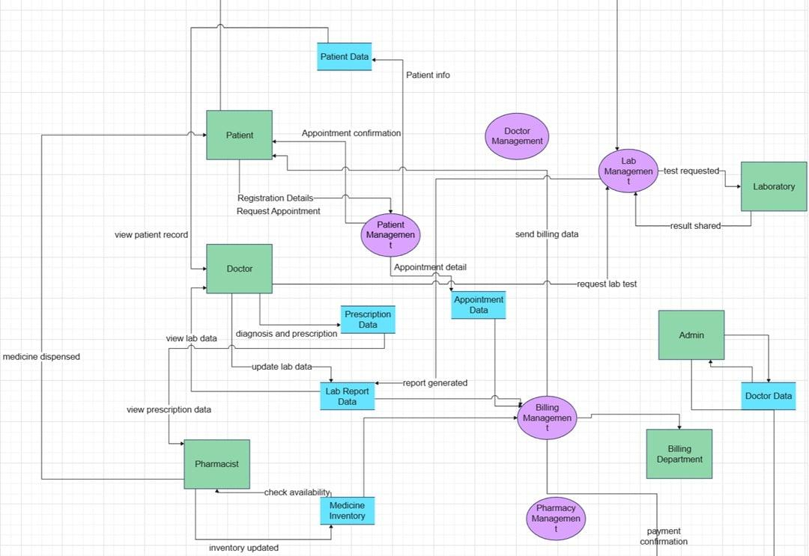
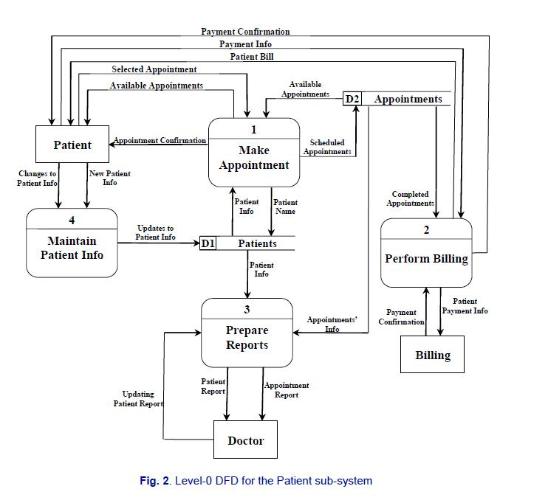
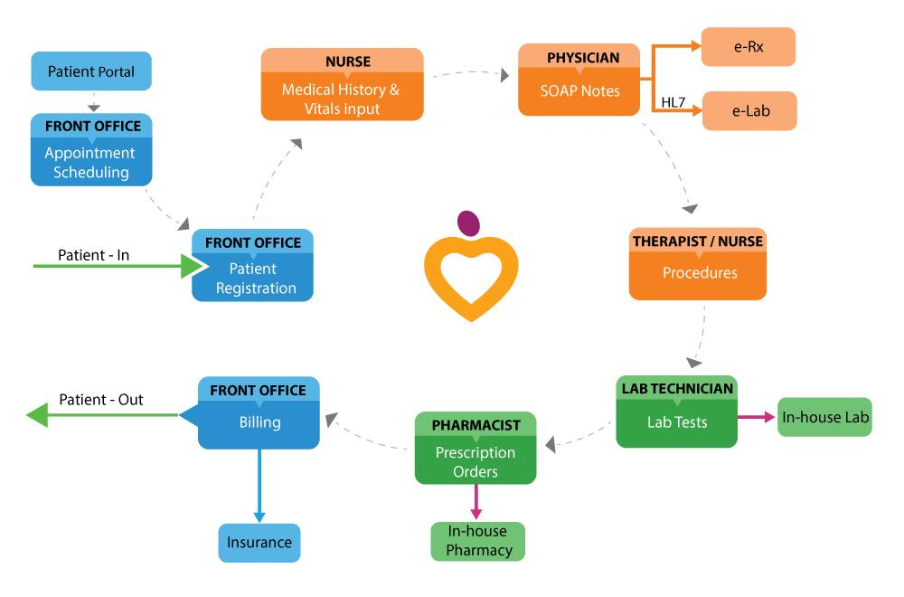
User Stories
User Type | Functional Requirement (Epic) | User Story Number | User Story / Task | Acceptance Criteria | Priority | Release
Patient | Registration / Login | USN-1 | As a patient, I can access the Medical Diagnostic Center portal using my account. | I can successfully access the patient portal. | High | Sprint-1
Patient | Browse Tests | USN-2 | As a patient, I can view the available diagnostic tests. | I can view the test name, category, description and price. | High | Sprint-1
Patient | Test Selection | USN-3 | As a patient, I can select a diagnostic test that I want to book. | The selected test is displayed correctly before booking. | High | Sprint-1
Patient | Appointment Booking | USN-4 | As a patient, I can book a diagnostic test by selecting an appointment date and time slot. | The appointment is created with the selected test, date and time. | High | Sprint-1
Patient | Patient Details | USN-5 | As a patient, I can enter my personal details while booking a test. | Patient details are saved successfully with the appointment. | High | Sprint-1
Patient | Payment | USN-6 | As a patient, I can complete payment for my selected diagnostic test. | Payment is processed and the payment status is updated successfully. | High | Sprint-2
Patient | Booking Confirmation | USN-7 | As a patient, I can receive confirmation after successfully booking a test. | Confirmation contains the appointment details and test information. | High | Sprint-2
Patient | My Appointments | USN-8 | As a patient, I can view my booked appointments and their status. | I can view pending, confirmed, completed or cancelled appointments. | High | Sprint-2
Patient | Appointment Cancellation | USN-9 | As a patient, I can cancel an eligible appointment. | The appointment status changes to cancelled successfully. | Medium | Sprint-2
Patient | Lab Reports | USN-10 | As a patient, I can view my laboratory reports after completing the diagnostic test. | The patient's available reports are displayed in the My Lab Reports page. | High | Sprint-3
Patient | Report Details | USN-11 | As a patient, I can view detailed information about my laboratory report. | Report number, test name, date, doctor and findings are displayed. | High | Sprint-3
Doctor / Lab Technician | Test Results | USN-12 | As a doctor or lab technician, I can enter and update diagnostic test results. | Test results are saved against the correct patient and appointment. | High | Sprint-3
Doctor / Lab Technician | Report Verification | USN-13 | As a doctor, I can verify laboratory reports. | The report shows the verification details after verification. | High | Sprint-3
Administrator | Test Management | USN-14 | As an administrator, I can add, update and manage diagnostic tests. | Diagnostic test information can be created and maintained successfully. | High | Sprint-1
Administrator | Appointment Management | USN-15 | As an administrator, I can review and update patient appointment status. | Appointment status is updated correctly in the system. | High | Sprint-2
Administrator | Report Management | USN-16 | As an administrator, I can manage patient laboratory reports. | Reports can be created, updated and associated with the correct patient. | High | Sprint-3
System | Notifications | USN-17 | As a system, I can send notifications for important appointment events. | The patient receives the appropriate appointment notification. | Medium | Sprint-3
System | Automatic Report Generation | USN-18 | As a system, I can automatically generate a laboratory report when an appointment is completed. | A report is automatically created and associated with the completed appointment. | High | Sprint-3

Overall User Journey
Browse Tests → Select Test → Enter Patient Details → Book Appointment → Make Payment → Confirmation → Test Completed → Laboratory Report Generated → View Report

